Chemistry 535 Final Examination – Mrs. Czyryca

June 2009 FORM A Name______________________
Directions: Answer PART I questions on the scantron sheet provided.
Answer PART II questions on the test sheet in the space provided
Only reference charts issued for this examination may be used
Calculators should be used, but they may not be shared during the examination.
PART I There are 50 multiple choice questions in part I. You have 50 minutes to complete part I.
You will have 40 minutes to complete part II.
Select the response that best completes or answers each statement.
Fill in the oval on your scantron sheet corresponding to the letter for the answer.
There is only one response for each question.

1. In an experiment to identify an unknown gas, it is found that 1.82 L of the gas has a mass of 5.430 g. What is the density of the gas in g/L?
a) 2.98 b) 0.335 c) 9.88 d) 0.101

2. Bonds between atoms with the greatest differences in electronegativity are
a) nonpolar covalent bonds b) polar covalent bonds
c) ionic bonds d) coordinate covalent bonds

3. Calculate the number of moles in 3.44 x 10²⁶atoms of beryllium.

a) 571mol Be b) 2.70 x 10⁴⁹mol Be c) 3.82 x 10²⁷mol Be d) 3.10x 10²⁵

4. All of the following are legitimate conversion factors except _____________.
a)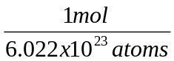 b) 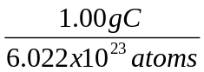

c) 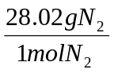 d) 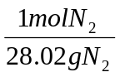

5. Which of the following is NOT true about the structure of an atom?

a) Protons and neutrons are tightly packed in the nucleus.
b) Electrons exist in the less dense region called the electron cloud.
c) Neutrons and electrons have nearly the same mass.
d) Most of the mass of an atom is contained in the nucleus.

6. Which set consists only of compounds?
a) Na, Ca, He b) H₃O⁺, Cl⁻, I₃⁻ c) NaCl, CH₄, Br₂ d) H₂S, CuCl₂, KI

7. Researchers are studying the stress levels of women. By taking an herbal drug called BeCalm’d, their stress levels should decline. Which of the following is the independent variable in this study?

a) stress b) gender c) the drug d) whether they exercise

8. Radioactivity is _______________________________.

a) when electrons are exchanged due to instability
b) when an explosion occurs and makes new products
c) the an ion fulfills the octet rule
d) when the nucleus is unstable and gives off subatomic particles and gamma rays

9. Imagine a hypothetical element “X” has two isotopes. Based on the data given below, the average atomic mass of element “X” is closest to:

Isotope | Isotopic Mass (amu) | Percentage of Naturally Occurring Isotope
⁴⁰X | 39.997 | 30.1%
⁴⁵X | 44.995 | 69.9%

a) 40.0 amu b) 42.5 amu c) 43.5 amu d) 45.0 amu

10. Which is the correct list of qualities of metals?

- shine brightly when polished; good conductors of electricity and heat; solid at room temperatures;
transparent

- good conductors of electricity and heat; solid at room temperatures; opaque, except in extremely thin
sheets; always dull

- ductile; good conductors of electricity and heat; solid at room temperatures; opaque, except in extremely thin sheets

d) poor conductors of electricity and heat; solid at room temperatures; opaque, except in extremely thin
- sheets;

11. Which one of the following does not represent one mole?
a) 6.022 x 10²³ sulfur atoms b) 13.0 grams of aluminum
c) 65.39 grams of zinc d) 200.59 grams of mercury

12. Chemical properties
a) include changes of state of a substance.
b) include mass and color.
c) include properties that are observed when the composition of a substance is altered.
d) can be observed without altering the identity of a substance.

13. Which of the following best describes an alloy of metals?
a) a compound b) a pure substance
c) a heterogeneous mixture d) a homogeneous mixture

14. Using an electronegativity chart, predict which individual bond is the most polar in ethanol, CH₃CH₂OH.
(shown here)

a) C—C b) O—H c) C—O d) C—H 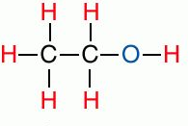

15. A substance that is compressible, has low density, and is fluid describes a ________________.

- solid b) liquid c) gas d) water

16. Temperature is ____________________.

a. the average kinetic energy of a substance b. energy transferred
c. how an object feels d. passing cold molecules to a hotter object

17. Isooctane, C8H18, undergoes combustion to form carbon dioxide and water. How many moles of oxygen gas are needed to react completely with 1.25 mole of isooctane?
2C8H18(l) + 25O2(g) → 16CO2(g) + 18H2O(g)
a) 31.2 mol b) 15.6 mol c) 12.5 mol d) 1.25 mol

18. Isotopes of an element differ in their ____________.
a) atomic numbers b) electron configurations
c) number of protons d) neutrons

19. When 10.0 g of magnesium react with 10.0 grams of oxygen, which substance will be used up first?
2Mg + O2 → 2MgO
a) Mg b) O2 c) both d) cannot be determined

20. 410,000,000m can be represented in scientific notation as _______________________.

a) 4.1 x 10⁷m b) 41 x 10⁻⁷m c) 4.1 x 10⁻⁸m d) 4.1 x 10⁸m

21. Which of the following elements do NOT exist as diatomic molecules?
a) C₂ b) I₂ c) Br₂ d) N₂ e) Cl₂

22. Which is the electron configuration of a neutral atom of a transition element?
a) 1s22s22p63s23p2 b) 1s22s22p63s23p6
c) 1s22s22p63s23p64s1 d) 1s22s22p63s23p64s23d2
23. Determine the percent yield when ZnI₄ dissociates and yields 44.5g of iodine. The theoretical yield is 48g I₂. ZrI₄(s) → Zr(s) + 2I₂(g)

a) 108% b) 93% c) 3.5% d) 7.0%

24. Determine which molecule is polar based on its shape.
a) AlF₃ b) CO2 c) NH3 d) CH₄

25. Glucose is soluble in water because _____________________________.
a) water forms hydrogen bonds with the oxygen in glucose
b) they are both nonpolar
c) glucose is nonpolar and water is polar
d) London forces occur between them

26. Classify the following reaction: 2C₂H₆(g) + 5O₂(g) → 4CO₂(g) + 6H₂O(g)
a. combustion b. decomposition c. Single replacement d. double replacement

27. A 2.4L balloon has a pressure of .988atm. If the volume changes to 2.8L, what is the new pressure?
a) 0.85 atm b) 6.8 L c) 0.15L d) 1.15atm

28. Convert 298K to degrees in Celsius.

- 571 °C b) 25°C c) 293°C d) 5°C

Refer to the solubility graph to answer questions 29-30.

29. How many grams of substance E can be dissolved in 1000g of water at 30˚
a) 32g b) 22g c) 43g d) 55g

30. How many grams of substance D will precipitate out of solution when it is cooled from 65˚C to 24˚C?

a) 57g b) 18g c) 40g d) 28g

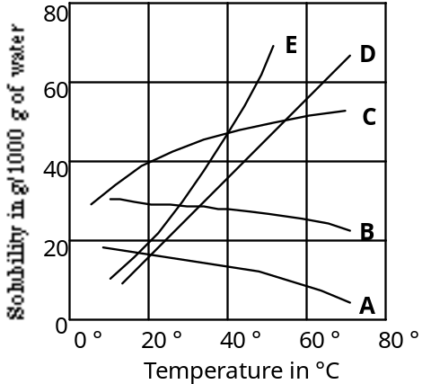

31. In chemical reactions, ionic bonds form due to the attraction of positive ions to ___________________.

a) negative ions b) the nuclei c) positive ions d) neutrons

32. Which one of the following models best represents a mixture?

a) 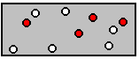 b) 

c)  d) 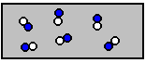

33. Which of the following is an example of a heterogeneous mixture?

a) gasoline b) marble c) bronze d) paint

34. Which of the following is generally true about a limiting reactant?

a) it is readily available b) there will be some left over c) it is expensive d) it is cheap

35. During a chemical reaction, the products that are formed are…

a) different compounds than the reactants. b) the same compounds as the reactants.
c) greater in mass than the reactants. d) always less stable than the reactants.

36. Which is a “physical change”?

a) vaporizing gasoline b) milk going sour c) wood burning d) rusting iron

37. The attractive forces that arise as a result of temporary dipoles induced in atoms or molecules are
called ________________ forces.
a. London dispersion b. dipole-dipole c. intramolecular d. covalent

38.

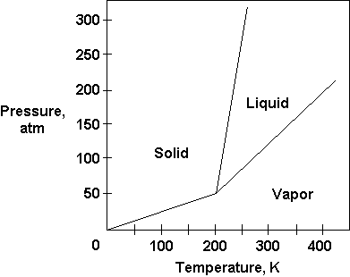

38. Using the phase diagram above. At 200atm, what is the temperature at which this substance freezes?

- 198K b) 250 K c) 300K d) 0 K

39. The volume of a balloon at 305K is 2.3L. If the temperature increases to 320.K during the day, what will the new volume be?

a) 2.4L b) 2.2L c) 34.5L d) 280L

40. Which is the correct list of qualities of ionic compounds?

a) weak bonds, high melting and boiling points, good conductors as liquids and in solution
b) strong bonds, low melting and boiling points, poor conductors as liquids and in solution
c) weak bonds, low melting and boiling points, good conductors when solid, electroneutral
d) strong bonds, high melting and boiling points, good conductors in solution, electroneutral

41. The charge on aluminum is +3, this is because ____________________.

a) Al needs to lose 3 electrons to be stable
b) Al needs to gain 3 electrons to be stable
c) Al needs to gain 5 electrons to be stable
d) Al ends in a p³ electron configuration

42. Which of the following does NOT represent an isotope of tellurium?

a) ¹²² Te c) ¹²⁸ Te
⁵² ⁵²

b) ¹²⁴ Te d) ¹²⁴ Te
⁵³

43. How many total atoms are there in the formula Fe(NO3)3?
a) 3 b) 5 c) 10 d) 11 e) 13

44. The theoretical yield is determined
a) by looking it up in a reference chart. b) by calculating it on paper.
c) by measuring the mass in the laboratory. d) randomly in your mind because it’s just a theory.

45. In the compound XF3, in order to make the compound electroneutral, the element X should be
a) aluminum b) neon c) rubidium d) calcium e) carbon

46. The ion of magnesium-24 contains
a) 12 protons, 12 neutrons, 12 electrons b) 12 protons, 12 neutrons, 11 electrons
c) 12 protons, 12 neutrons, 10 electrons d) 12 protons, 24 neutrons, 10 electrons

47. 20.0 kilograms are equal to how many milligrams?
a) 2.00 x 10-7 b) 2.00 x 10-6 c) 2.00 x 105 d) 2.00 x 106 e) 2.00 x 107

48. Chose the TRUE statement about the following chemical reaction.
200kJ + CO(g) + 2H₂(g) 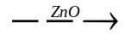 CH₃OH(g)

a) Palladium is a catalyst b) it is endothermic
c) it must be heated to 300° d) it is unbalanced

49. Which is the conjugate base of water, H₂O?

a. H⁺ b. H₂O c. H₃O⁺ d. OH⁻

50. Which of the following ions is NOT isoelectronic with neon?
a) F⁻ b) O⁻² c) Cl⁻ d) Na⁺ e) Mg⁺²

End of Multiple Choice-turn in and pick up short answer

SCRAP PAPER-TURN IN WITH TEST

If you detach this from the test, put your name here

_________________________________________

Chemistry 535

Final Exam 2009 A

Mrs. Czyryca
You MAY write on this exam

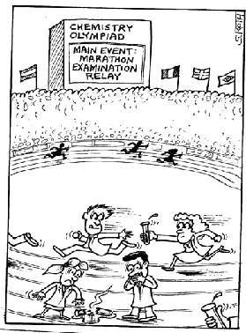

Name _______________________
Period___________

